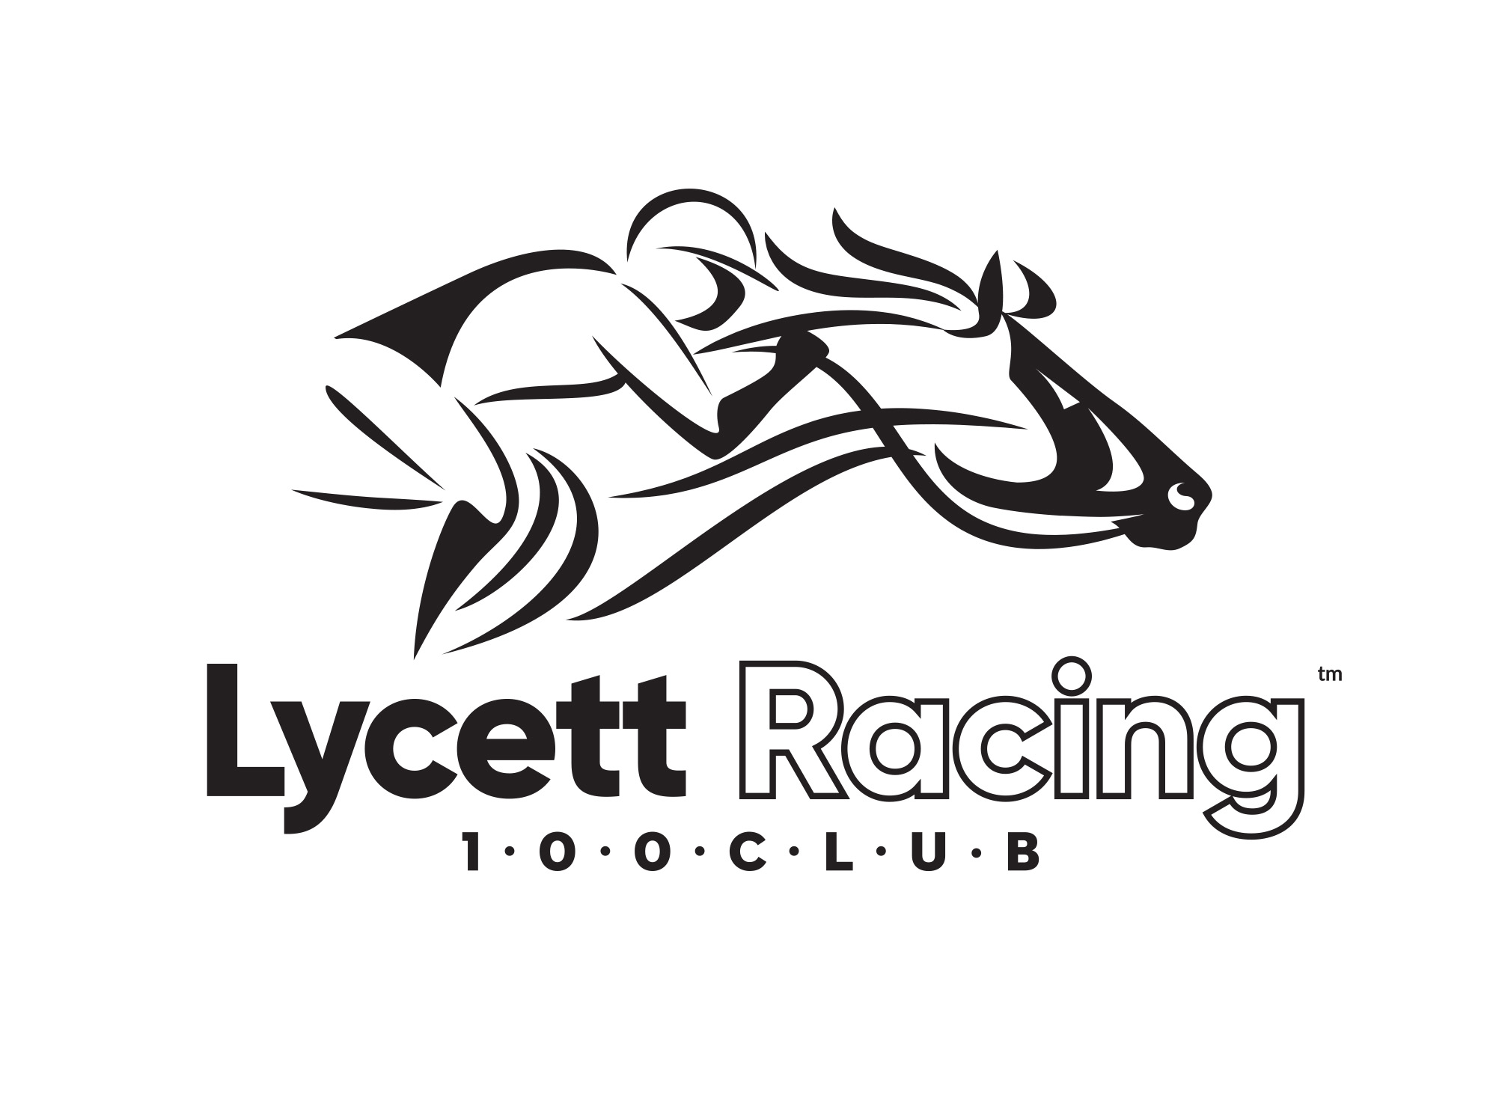
MEMBERSHIP APPLICATION FORM

PLEASE COMPLETE THE DETAILS BELOW IN BLOCK CAPITALS TO GUARANTEE LEGIBILITY.
PLEASE DOUBLE-CHECK THAT THE EMAIL ADDRESS AND MOBILE NUMBER FIELDS ARE COMPLETED CORRECTLY AS THESE ARE ESSENTIAL TO ACTIVATING YOUR ACCOUNT.

Name:
Postal Address: Postcode:
Email:
Mobile:
Date of Birth: / /
I confirm that I have read and agree to the enclosed Terms & Conditions (please tick)
We will keep you regularly updated with information regarding your membership benefits and other horse-related info that we feel is relevant to you. Please tick the following box to give your consent to receive information via email, text messages and/or social media NB: You may miss out on certain benefits of the Club membership if you do not consent to receive our messages.

PLEASE POST COMPLETED FORM TO LYCETT RACING 100 CLUB, HERITAGE HOUSE, ILKESTON, DERBYSHIRE, DE7 5UD OR SCAN AND EMAIL TO INFO@LYCETTRACING.CO.UK
For office use only:
Application received (date) / /
Direct Debit set up (date) / /
1st payment to be taken on / /
Membership number: LR1001

